Creating a game where both a human player and the computer take turns clicking on a dot in Scratch 3 is a fun project. We will make a version where both a **human** and the **computer** take turns trying to click the dot, and the goal is to score the most points within a given time.

### Full Code Implementation

Here's how you can implement the full game using **Scratch 3** where both the human and the computer play as opponents:

### Step 1: Set Up the Stage and Sprite

1. **Backdrop**: Keep a simple backdrop.
2. **Dot Sprite**: Choose a circle sprite (or draw your own dot).

### Step 2: Create Variables

You need some variables to track the game’s state:

1. **Human Score**: Tracks the human player’s score.
2. **Computer Score**: Tracks the computer's score.
3. **Time**: Keeps track of how long the game runs (countdown timer).
4. **Turn**: Tracks whose turn it is (Human or Computer).
5. **Rounds**: Optional if you want to limit turns, e.g., after a certain number of turns, the game ends.

### Step 3: Initialize Variables

1. Go to the **Variables** section and create the following:
   1. Human Score
   2. Computer Score
   3. Time
   4. Turn
   5. Rounds (optional)

### Step 4: Human and Computer Alternating Turns

You need to alternate between the human and computer taking turns.

**Initialize Game:**

* 1. Set the starting values of scores, time, and turn when the game begins.
  2. Start with the **Human's Turn**.

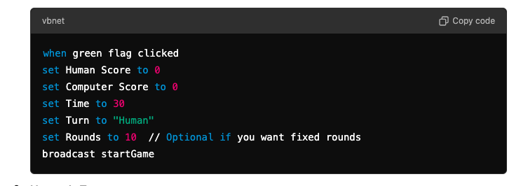

**2.Human’s Turn**:

* 1. When it’s the human’s turn, the human has to click the dot to score.
  2. Use the when this sprite clicked event to detect clicks and increase the human's score.

**Code for Human's Turn**:

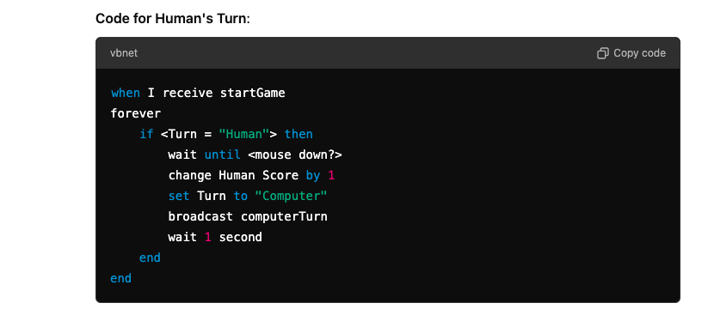

**3.Computer’s Turn**:

* 1. For the computer, we can simulate a click by making it select a random time to "click" on the dot.
  2. You can create randomness in whether the computer scores by introducing a pick random 0 to 1 condition.

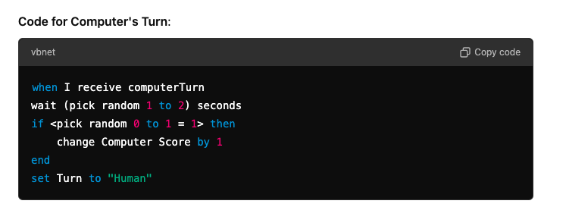

### Step 5: Dot Movement

To keep things challenging, you need the dot to move around randomly. Both the human and computer will have to "click" the dot as it moves.

1.**Random Movement**:

* 1. Make the dot move to a random position every second.

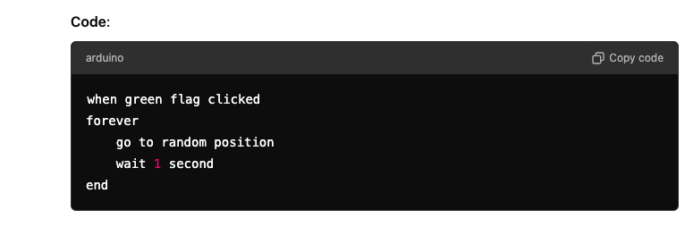

### Step 6: Add a Timer and Game End

You can limit the time for each game by adding a countdown timer, and stop the game when the time is over.

**1.Timer Countdown**:

* 1. Create a countdown from 30 seconds (or any time you prefer).
  2. Once the time runs out, stop the game.

**Code for Timer**:

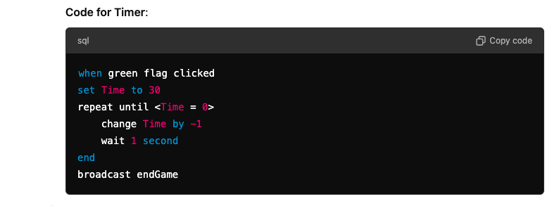

**2.End the Game**:

* 1. When the game ends, announce the winner based on who has the highest score (Human or Computer).
  2. Use the say block for this.

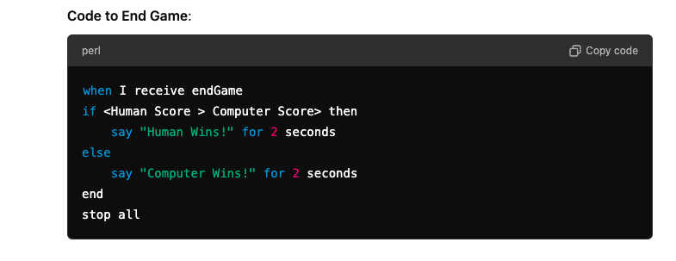

### Step 7: Optional Rounds Limitation

If you want to limit the number of rounds (e.g., 10 rounds), you can add an additional variable (Rounds) and reduce it after each turn.

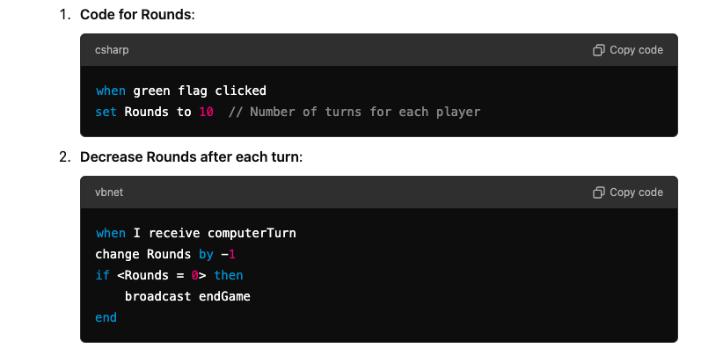

### Final Game Flow Summary:

1. The game starts, and the **human** takes the first turn to try and click the dot.
2. After the human clicks, the turn switches to the **computer**, and the computer "clicks" the dot using random logic.
3. The dot moves randomly across the screen every second to make it harder to click.
4. The game continues for a set time (e.g., 30 seconds) or a fixed number of rounds (e.g., 10 turns each).
5. When time runs out or rounds end, the game stops, and the winner is declared based on who has the higher score.

This gives you a basic two-player (human vs. computer) game in Scratch 3! You can further tweak this by adding extra features like difficulty levels, sounds, and visual effects.